|  |  |
| --- | --- |
| Nikon AF-S 50mm F/1.8G lens  Ống kính Nikon AF-S 50mm F/1.8G  Ống kính Nikon 50mm F1.8G.1 Ống kính Nikon 50mm F1.8G.4 Ống kính Nikon 50mm F1.8G.6 Ống kính Nikon 50mm F1.8G.2 | **Featured information:**  Anti-vibration: No  Aperture: F/1.8-16  Closest focusing distance: 45cm  Filter size: 58mm  Price: $ 1200  **Specifications:**  Focal distance  50mm  Largest Aperture  f/1.8  Smallest Aperture  f/16  Lens Mount  Nikon F  Lens Format  Full-Frame  View  47°  Minimum Focus Distance  45 cm  Magnification  0.15x  Optical Components  7 Elements in 6 Groups  Number of Mouth Blades  7  Focus Type  Autofocus  Anti-Vibration |

**Overview:**

- Used for Full-Frame sensors - Focal length: 50mm - Lens mount: Nikon F - Aperture: F/1.8-16 - Closest focusing distance: 45cm - Number of aperture blades: 07 - Anti-shake: No - Filter size: 58mm - Weight: 185g

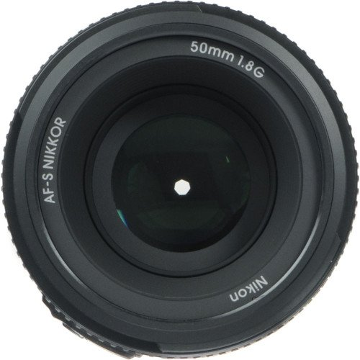

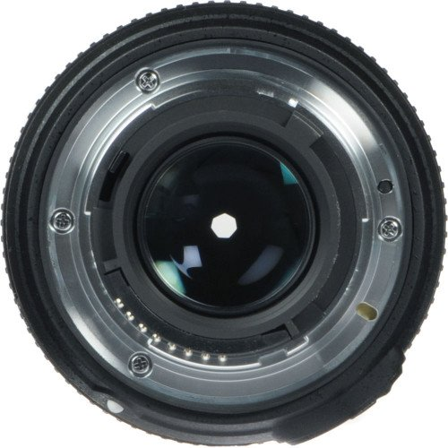

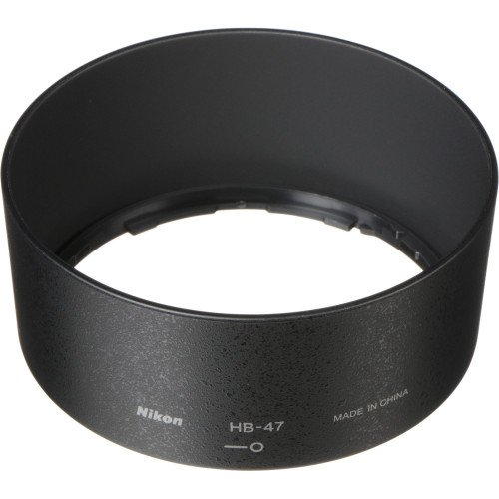

Used for Full-Frame sensor - Focal length: 50mm - Lens mount: Nikon F - Aperture: F/1.8-16 - Closest focusing distance: 45cm - Number of aperture blades: 07 - Anti-shake: No - Filter size: 58mm - Weight: 185g

+ See details